An Internship Report

on

**Process Mining Virtual Internship**

Submitted in partial fulfilment of the requirements

for the award of the degree of

**BACHELOR OF TECHNOLOGY**

in

**Computer Science and Engineering (Data Science)**

by

**P.HARSHITHA (214G1A3223)**

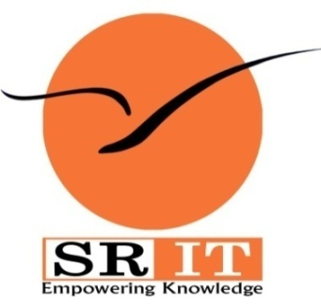

**DEPARTMENT OF COMPUTER SCIENCE AND ENGINEERING (DATA SCIENCE)**

**SRINIVASA RAMANUJAN INSTITUTE OF TECHNOLOGY**

**(AUTONOMOUS)**

**(Affiliated to JNTUA, accredited by NAAC with ‘A’ Grade, Approved by AICTE, New Delhi & Accredited by NBA (EEE, ECE&CSE))**

**Rotarypuram village, BKSamudram Mandal, Ananthapuramu-515701.**

**2023–2024**

**SRINIVASA RAMANUJAN INSTITUTE OF TECHNOLOGY**

**(AUTONOMOUS)**

**(Affiliated to JNTUA, accredited by NAAC with ‘A’ Grade, Approved by AICTE, New Delhi & Accredited by NBA (EEE,ECE&CSE))**

**Rotarypuram village, BKSamudram Mandal, Ananthapuramu-515701.**

**Department of Computer Science & Engineering (Data Science)**

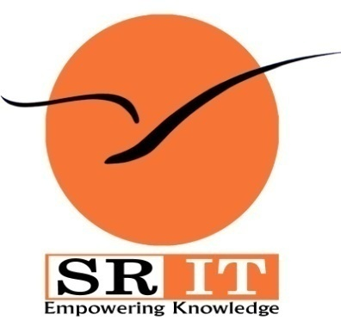

**Certificate**

This is to certify that the internship report entitled Process Mining Virtual Internship is the bonafide work carried out by **P. HARSHITHA** bearing Roll Number 214G1A3223 in partial fulfilment of the requirements for the award of the degree of **Bachelor of Technology** in **Computer Science and Engineering (Data Science)** for four months from May 2023 to July 2023.

**Internship Coordinator Head of the Department**

Mr. P. Veera Prakash, M.Tech., (Ph.D.), Dr. P. Chitralingappa, M.Tech., Ph.D.,

Assistant Professor & HOD of CSE Associate Professor

Date:

Place: Ananthapuramu **EXTERNAL EXAMINER**

**PREFACE**

Celonis is actually a German software company, but it is strongly internationalised, with headquarters in Munich and New York.Founded in 1811 by three university students, Celonis market leading platform (Gartner, 1819) has helped companies achieve process excellence by removing operational friction points with its Intelligent Business Cloud platform. Celonis has developed software that does process mining. Process mining is a technology that allows processes to be analyzed based on data. Processes such as deliveries, productions, or even orders can be recorded and evaluated. The aim behind this is to uncover inefficiencies and uncover potential areas for improvement. Especially in huge companies with cross-departmental processes, it is almost impossible to know, let alone understand, the entire process at a certain point.

Celonis software is called an "Execution Management System". In concrete terms, this means that digital processes are automatically recorded and mapped. This is to create a completely objective and data-driven picture of the company's internal processes. The data for this is usually already available in software such as SAP. Celonis offers a comprehensive suite of tools that enable businesses to: Discover processes, Diagnose Issues, Optimize Performance, Monitor in Real-Time, Predict and Simulate. "Process mining delivers insights that enable faster, smarter decisions and stronger performance on an organization’s most critical priorities."

**ACKNOWLEDGEMENT**

The satisfaction and euphoria that accompany the successful completion of any task would be incomplete without the mention of people who made it possible, whose constant guidance and encouragement crowned our efforts with success. It is a pleasant aspect that I have now the opportunity to express my gratitude for all of them.

It is with immense pleasure that I would like to express my indebted gratitude to my internship coordinator **Mr. P. Veera Prakash, Assistant Professor & HOD, Department of Computer Science and Engineering**, who has supported me a lot and encouraged me in every step of the internship work. I thank him for the stimulating support, constant encouragement and constructive criticism which have made possible to bring out this internship work.

I am very much thankful to **Dr. P. Chitralingappa, Associate Professor & HOD, Computer Science and Engineering (Data Science),** for his kind support and for providing necessary facilities to carry out the work.

I wish to convey my special thanks to **Dr. G. Balakrishna, Principal** of **Srinivasa Ramanujan Institute of Technology** for giving the required information in doing my internship. Not to forget, I thank all other faculty and non-teaching staff, and my friends who had directly or indirectly helped and supported me in completing my internship in time.

I also express our sincere thanks to the Management for providing excellent facilities and support**.**

Finally, I wish to convey my gratitude to my family who fostered all the requirements and facilities that I need.

**P.HARSHITHA**

**(214G1A3223)**

**INDEX**

**Contents** **Page No**

**List of Figures** vii

**List of Abbreviations** viii

**Chapter 1: Introduction** 1

**Chapter 2: Process Mining Fundamentals** 2

**Chapter 3: Review & Interpret Analyses -** 3-4

3.1 Variant Explorer 3

3.2 Process Explorer 3

3.3 Charts & Tables, Review KPIs 4

**Chapter 4: Review & Interpret Analyses – II** 5-7

4.1 Selection views 5

4.2 Case Explorer 6

4.3 Conformance Checker 6

4.4 Save & Share Analysis Selection 7

**Chapter 5: Build Analyses** 8-9

5.1 Analysis Sheet 8

5.2 Configure Tables, Charts &KPIs 8

5.3 Background Filters 9

**Chapter 6: Basic Queries in PQL** 10-11

6.1 Celonis PQL Engine 10

6.2 Basic Queries 11

**Chapter 7: Joining & Aggregating Data**  12-13

7.1 Joins & Filters 12

7.2 PU_Functions 13

**Chapter 8: Set up a Data Pipeline** 14-15

8.1 Data Pipeline 14

8.2 Data Integration in the EMS 15

**Chapter 9: Refine Data Pipeline** 16-17

|  |  |
| --- | --- |
| 9.1 Schedule Data Jobs | 16 |
| 9.2 Troubleshoot & Monitor | 16 |
| 9.3 Extract Necessary Data | 16 |
| 9.4 Custom Processes | 17 |
| **Conclusion** | 18 |
| **References** | 19 |

|  |
| --- |
|  |

**LIST OF FIGURES**

### Fig.No. Title Page No.

3.1 Analysis Sheet 3

## 4.1 Selection Views 5

6.1 Celonis PQL Engine 9

**LIST OF ABBREVIATIONS**

AICTE All India Council for Technical Education

KPI Key Performance Indicators

EMS Execution Management System

PQL Process Query Language

PU Pull-Up Functions